Résumé des articles

Article 1: **Building Understanding of Smart City Initiatives**

This study aims to build a new understanding of smart city initiatives. Recent stud-ies have conceptualized and defined a smart city in various contexts and meanings [3], [6], [18]. Some working definitions merit attention :

1. Washburn et al. [27] emphasized technology by defining a smart city as “the use of smart computing technologies to make the critical infrastructure components and services of a city––which include city administration, education, healthcare, public safety, real estate, transportation, and utilities––more intelligent, interconnected, and efficient”
2. Anavitarte and Tratz-Ryan (role of information and communication technologies): “an urban area functioning and articulated by mod-ern information and communication technologies in its various verticals, providing ongoing efficient services to its population.”
3. Natural Re-sources Defense Council : a city striving to make itself smarter (more efficient, sustainable, equitable, and livable)”
4. Giffinger et al. : “a city well per-forming in a forward-looking way in economy, people, governance, mobility, envi-ronment, and living, built on the smart combination of endowments and activities of self-decisive, independent and aware citizens.”

* the role of technologies, the meanings underlying a city’s smart-ness, and a set of components representing the smartness of a city.
* The eight categories the preliminary framework suggests include technology, management and organization, policy, governance, people and communities, economy, built infrastructure, and natu-ral environment.

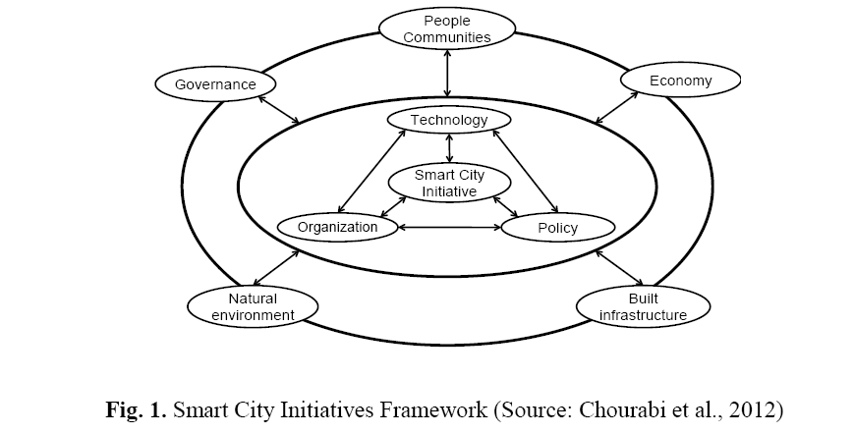

Interviewees talked more about technology, management and organization, policy context, and governance, than the other areas.

Voir tableau importance des différents éléments de framework

Article 3 : **Engaging the Public in Open Government: Social Media Technology and Policy for Government Transparency**

L’obligation de mettre la population au cours pour rcevoir les feeds back ainsi que la participation dans la gouvernance collective.

Il faut savoir les droits de chacun des parties prenantes et de connaître les différentes responsabilities.

L’article parle aussi de pb de langage, de l’âge, la familiarisation avec les différents outils administratif(ordinateur), ainsi qu’à la limitation à l’accès à l’internet .

Cette article est un peu ancien date de 2010.

Article 4 : **Crowdsourcing global governance: sustainable development goals, civil society, and the pursuit of democratic legitimacy**

Crowdsourcing is a process through which the completion of a task normally delegated to

employees is outsourced to a larger network of people (e.g., ‘‘the crowd’’) (Geiger et al.

2011, 1).

the essential elements of this process include: ‘‘…an organization that has a task it needs performed…a community (crowd) that is willing to perform the task voluntarily…an online environment that allows the work to take place and the community to interact with the organization, Crowdsourcing global governance: sustainable development goals… and…mutual benefit for the organization and the community’’ (Brabham 2013, 3).

In the area of global environmental governance, crowdsourcing is a new and underexplored

method of global civic engagement. Crowdsourcing provides a means of

expanding participation in agenda-setting and policy development processes in a way that

is potentially faster and more inclusive than has been possible at any other time in human

history.